(a)

Aromatic rings can be brominated using Br2 in the presence of FeBr3. The electrophile is Br . Friedel-Crafts acylation reaction occurs when an aromatic compound is treated with an acyl chloride in the presence of AIC13. The electrophile is RCO+. In aromatic electrophilic substitution reactions, the methoxy group is an ortho and para directing and activating group.

The methoxy group attached to the benzene ring is an ortho & para directing group. When methoxybenzene is brominated and alkylated it directs the incoming electrophiles, Br and CH3CO+ to ortho & para positions.

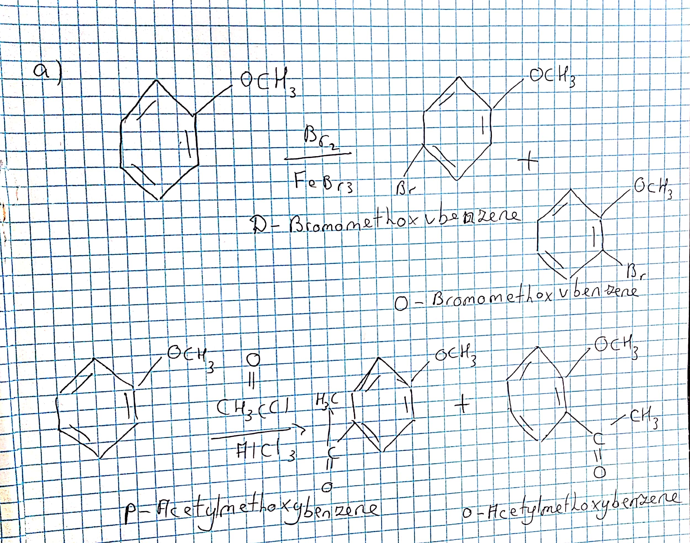

(b)

Electrophilic substitution of disubstituted benzenes follows three simple rules. (i) If The directing influence of both the substituents reinforce each other, a single product results. (ii) If The directing influences of both the substituent groups oppose each other, the most powerful activating group among them has the dominant influence but usually a mixture of products results. (iii) In meta disubstituted compounds, further substitution in between the groups occurs only rarely, due to steric reasons.

The aldehydic group is a meta directing deactivating group while the methyl group is an ortho and para directing activating group. Thus both methyl and aldehyde groups can direct the entering electrophile into the same position, ortho to methyl and meta to aldehydic group. Thus the Br atom and -COCH3 group get substituted at a position ortho to methyl and meta to aldehydic group.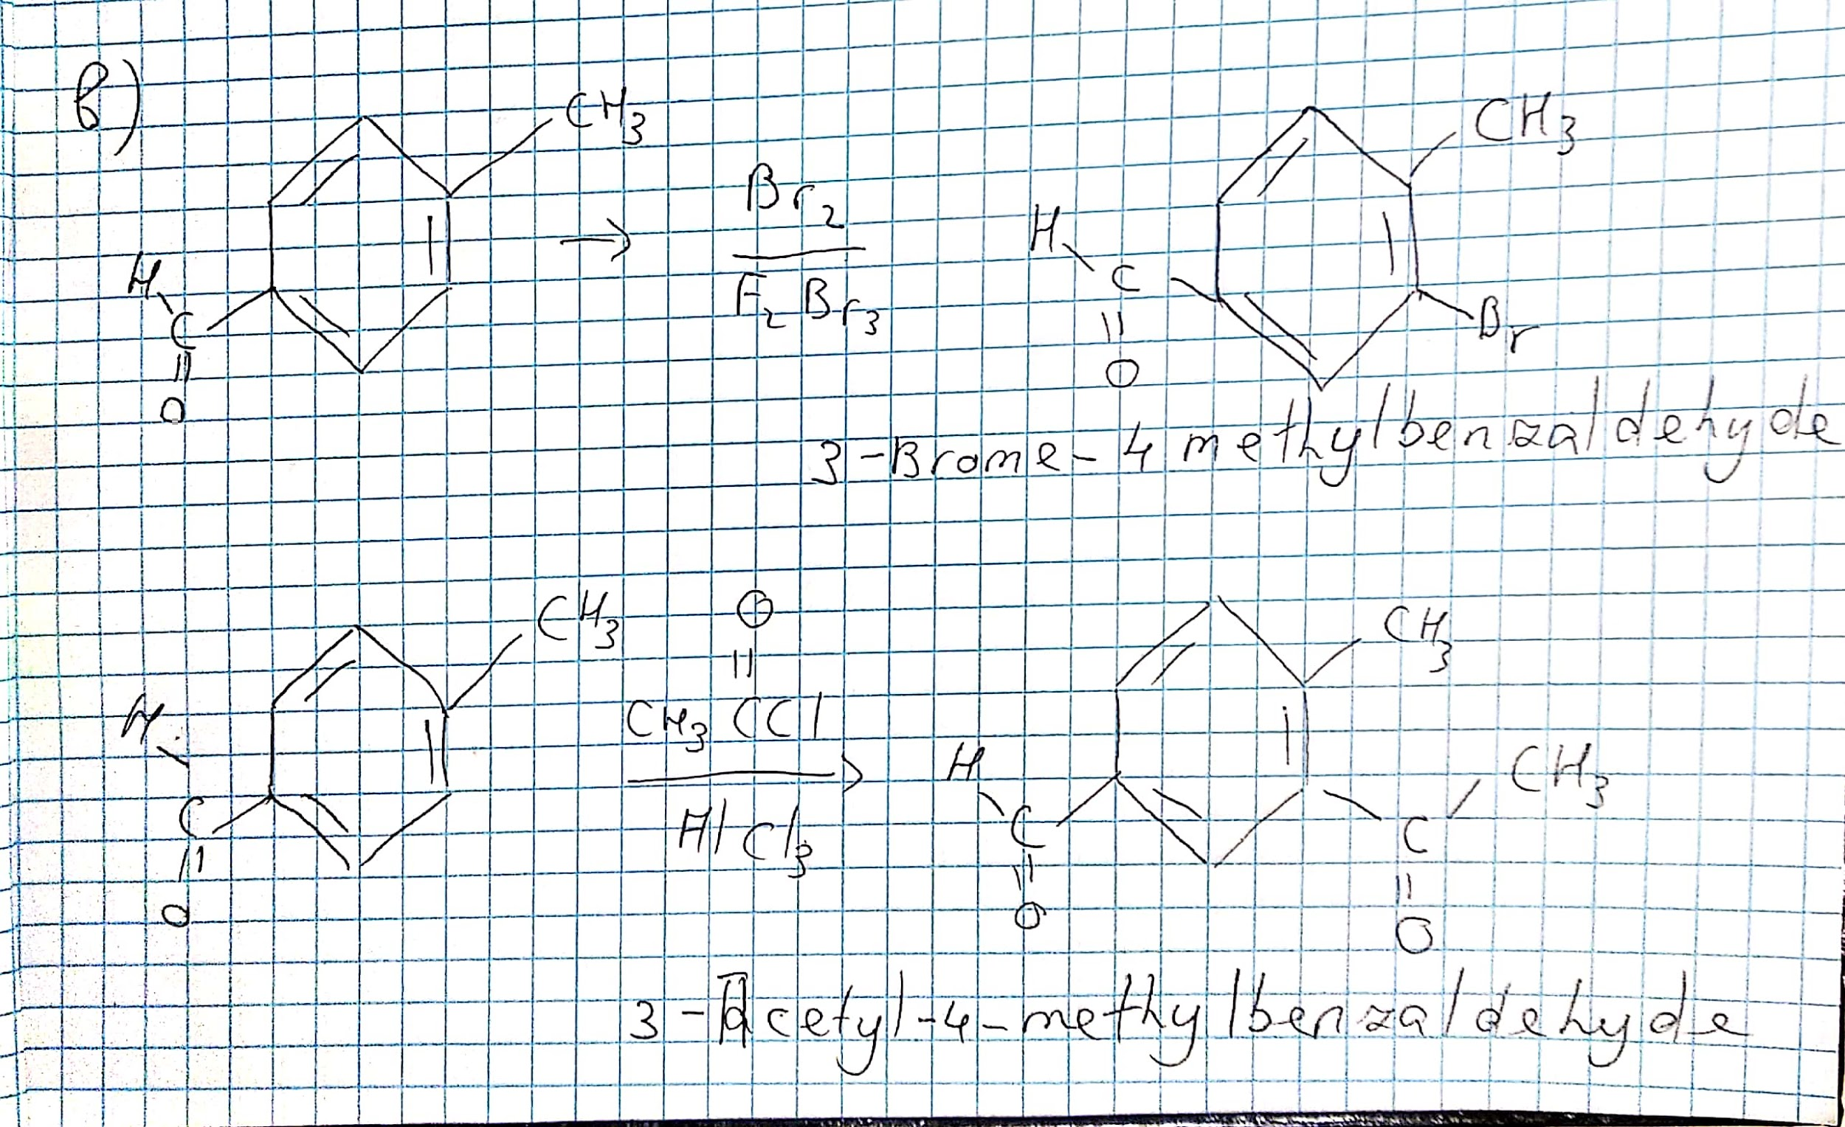

Thank you

Student ID : 201923250

Name : Kobilov Ilkhomjon